

Juanita is 28 years old and struggles to keep her weight in check. Both her mom and her aunt suffer from diabetes and she sees how this has impacted their health. She’s worried that one day she, too, will develop a condition and she wants to know how she can prevent this from happening.

Millions of Americans of all ages are like Juanita. Some have already developed a chronic condition such as diabetes or heart disease. Others are struggling to prevent one. That’s why we decided to create KPDailyCheckup.

Our new app enables users take charge of their health by helping them set goals for diet and exercise, so that they can prevent a condition, or manage or reverse a condition that they already have. What good is a plan if you’re not motivated to follow it? We’ve thought about that, too. That’s why we have developed “Challenges,” which allow users to obtain discounts and/or coupons from fitness clubs and other health product vendors if they meet a given activity goal within a time period.

In the five weeks since launch, we have acquired more and more new users each week, for a grand total of 38,000 new users:

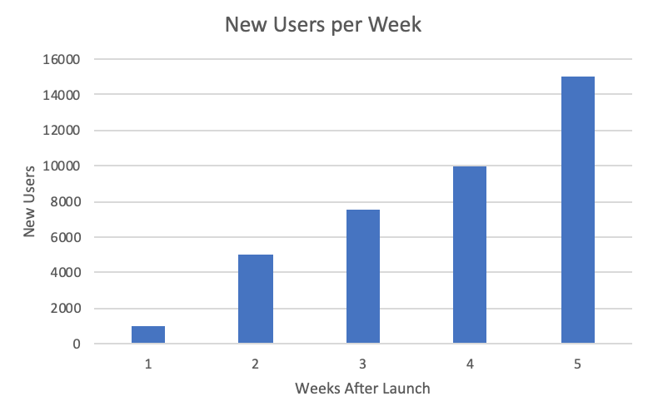

Additionally, user retention continues to grow:

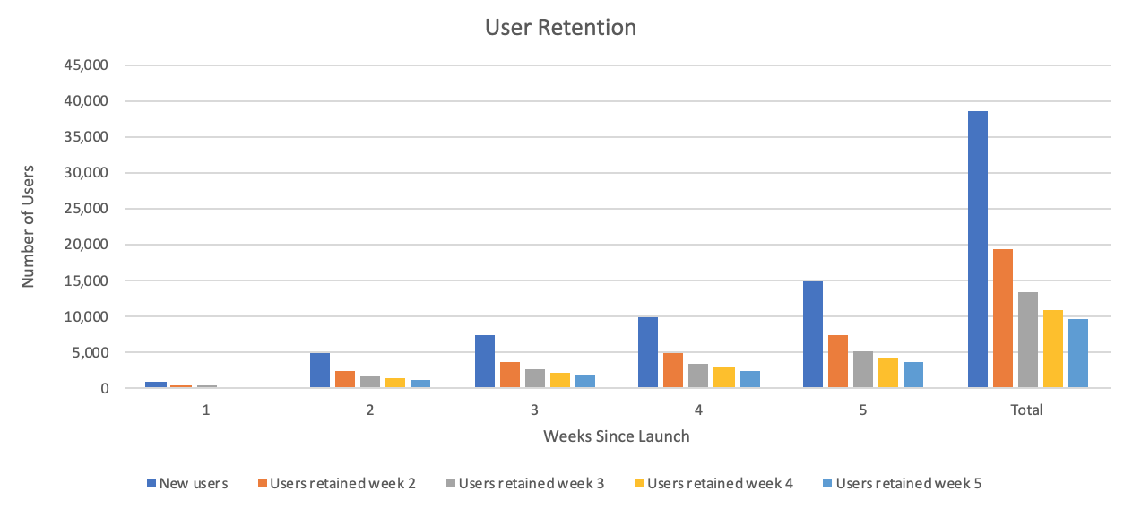

We think this is phenomenal and will continue to evaluate how we can improve the app for our users.

Throughout the remainder of the year we will continue to develop more capabilities. We will expand chronic care management for diabetes and cardiovascular disease patients. We will improve person health planning by integrating medical history data to better asses personal risk factors. Finally, we will develop new stress management and mental wellness features.

Thank you,

Maleina Bidek

on behalf of the KPDaily Checkup Team:
Alex King
Yuva Murugan
Anastasia Root

